“Motivations and Motivators”
To attend…to share… to work… to use… to comply… to eat… to listen… etc.
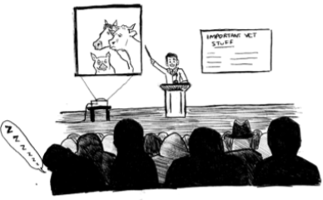
VPHA & AGV Autumn Hybrid Virtual/In-Person Conference
Eastwood Hall, Mansfield Road, Eastwood, Nottingham, NG16 3SS
27th-28th September 2024

STUDENT POSTER COMPETITION
(Undergraduate & postgraduate)

Applications are invited from students to submit public health or animal health/welfare or environmental sustainability related posters to present either in-person or virtually.
*Deadline for submission to rmw40@cam.ac.uk 16th September 2024*

Posters may be either:
Conceptual Ideas
Research ideas or proposals, theoretical concepts, policy or discussion points
Research
Quantitative, qualitative, lab-based

NB/ No longer than one page please

Undergraduate and postgraduate entries will be judged separately

Resources available to help making academic posters: https://libguides.ncl.ac.uk/academicposters

Please fill in the details below and send to Rhiannon Wood (rmw40@cam.ac.uk) along with a PDF of your poster. Feel free to discuss your topic and poster with your VPH teacher. If you have any questions, please do not hesitate to contact us.

Name and current affiliation

Undergraduate/Postgraduate
(please delete as appropriate)
Contact details including email

Title of poster
Brief outline of poster and the overall impact/perceived impact of work/idea on humans, non-human animals and/or the environment

